Project: Screening Boxes
Difficulty: Level 1

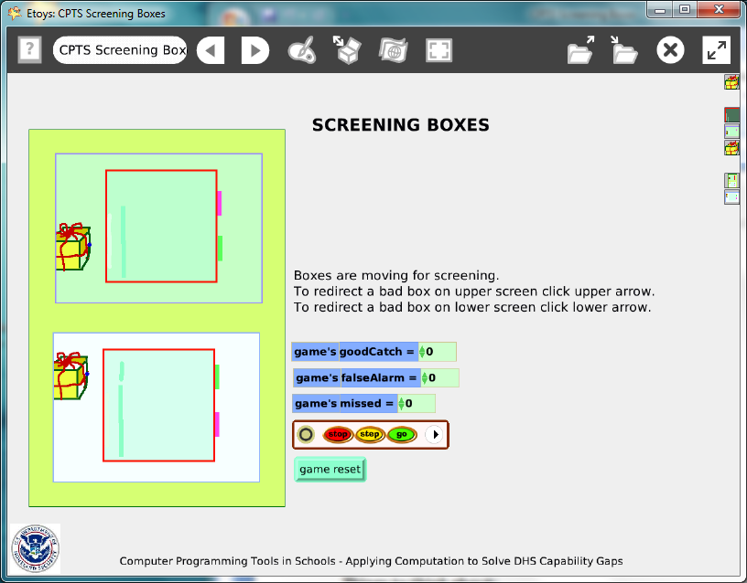

Project: http://etoysillinois.org/library?tags=Computer%20Programming%20Tools%20in%20Schools

Video Preview: http://www.youtube.com/watch?v=UgXnYCSRceA
The Preview Video's lesson worksheets focus on observations and analysis of events in the video; see page 4.

Time: Five 45 minute labs

Challenge:
Design a method to screen packages to prevent the importation of contraband. Include variables to track how many contraband boxes were stopped, how many false alarms occurred and how many were missed.

Programming:
The project’s scripting includes a number of variables and conditional statements. The use of watchers provides a way to show a score as the project is running. There are two screening stations but once all of the scripts are made for one station and the packages, they are copied for station 2. Discuss with students the importance of planning and precision when making scripts that will be used by more than one object.
Things you’ll need to know:
Playfields are used in this project. Spend a little time looking at the menus and script tiles available for playfields.
Quick Guides
- Paint Tools/ All
- Halo Handles/All
- Supplies: Text, All Scripts
- Script Tiles: Forward by, X and Y Tiles, Heading, World Input, Random Numbers, Tests Category, Two Color Test
- Menus: Normal Ticking, Viewer Icons Set, Scriptor Icons Set, Button Fires a Script, Watchers

Things to think about:
The use of playfields within playfield is a way to control actions of objects. Could this project be done without using playfields?

Extensions:
The second station increases the challenge of the game. How else could this game be made more challenging? Consider a time limit, the speed of the packages through the screening window, the amount of time the contents are revealed and how soon. Experiment with finished projects to see how long a person can sustain their full attention on screening? Does the error rate change over time? Does the error rate improve at slower speeds? Do slower speeds increase boredom and job fatigue?

NETS for Students:
http://www.iste.org/standards/nets-for-students/nets-student-standards-2007.aspx
1. Creativity and Innovation: a, b, c, d
2. Communication and Collaboration: a, b
3. Research and Information Fluency: a, b, c, d
4. Critical Thinking, Problem Solving, and Decision Making: a, b, c, d
5. Digital Citizenship: a, b
6. Technology Operations and Concepts: a, b, c, d

CSTA:
CSTA Level II: Objectives and Outline
http://csta.acm.org/Curriculum/sub/CurrFiles/L2-Objectives-and-Outlines.pdf
Level II objectives for middle school students are furthered through studying a programming language well enough that the student is proficient with it. Whether the language is Etoys, StarLogo TNG, or Scratch, it is the ability to use the language to express ideas that is valuable. A student skillful enough to use any programming language to express ideas, solve problems, model behaviors, simulate data, or to educate or entertain is an entitled person in today’s society.
Topics of particular note are:
Topic 2: Problem Solving
Topic 6: Connections between Mathematics and Computer Science
Topic 11: Programming Languages
Topic 13: Multimedia

Common Core Standards Mathematics:
http://www.corestandards.org/the-standards/mathematics
6. SP.5.b
7. SP. 1, 7. SP.5

Teacher Notes
Materials:
Border security is always being challenged. Read about and discuss current events regarding the smuggling of contraband, drugs, banned exotic animal or plants. Discuss how this process of screening could be improved. Discuss issues such as whether it is better to have missed contraband or to have had too many false alarms.

Comments: Objects - Scripts – Decisions
The box has one variable, its faultRate and two scripts: move and reset.
The conditional statement about whether a box should look like a good box or a bad box uses a scripting tile found in the graphics category of tiles. The screening stations’ conditional statements use variables created for the box and the game playfield and keep track of the scoring. The variables for the game are created in the playfield that has been named “game”. This playfield has a reset script.

Example Scripts:
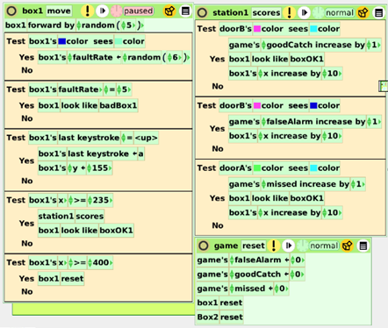

Student Notes:
None provided
Screening Boxes.mp4
Teacher Notes

This little movie is designed to be used in three ways:

• You can show it to teachers, parents, administrators or other community members as a way to build interest in bringing computer science into the k-12 curriculum.

• You can show it to students to foster discussion about airport screening. (See Activity #1)

• You can show it as a model for a project you will later have the students build for themselves in Etoys. (See Activity #2)

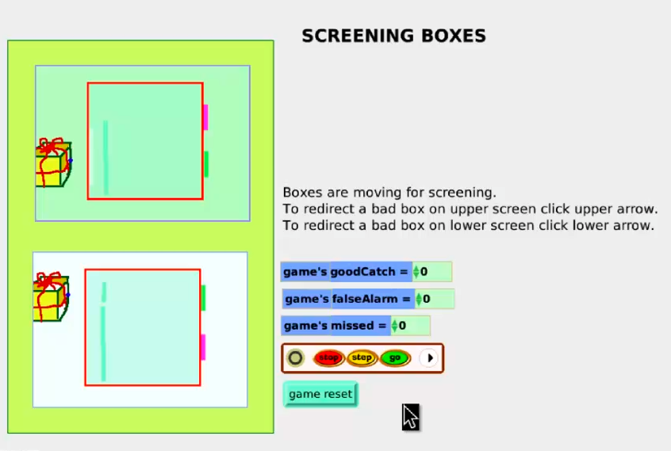

Flu Infection.mp4
Activity #1

This little movie shows a simulation of x-ray machines at an airport. The focus of this activity is to have the students make observations about what they see happening as a “bad box” passes through a machine. They will also speculate about how the effects they see may have been accomplished by the program. Working in groups of two or three, they will fill in the worksheet below and then discuss, as a class, what additional information they may want to research. Each group should have a computer and be allowed to watch the movie as often as they need.

The Lesson:

The teacher should introduce the activity by talking a bit about the use of x-ray machines today for screening people and boxes (luggage, purses, etc.) as they enter airports (court houses, schools, etc.) The teacher should then show the movie to the class as a whole. After showing the movie once, the teacher should tell the students that they will, in groups, answer questions about what they observe by watching the movie again. They will also be asked determine what additional questions might need to be asked in order to determine how they think this simulation was designed.

At the website:
http://etoysillinois.org/library?tags=Computer%20Programming%20Tools%20in%20Schools

You will find the actual applet, and teacher information.

There are many websites for doing research on screening. Below is one from the transportation Safety Administration: www.tsa.gov/what_we_do/screening/index.shtm

Answers to the questions on the following worksheet will vary, but general consensus should be reached before proceeding to the research phase.

Screening Boxes Observations Group Members ____________________

You may watch the movie as often as you want in order to answer or formulate your questions.

1) What behaviors do you observe as boxes pass through the screening machines? (Hint: Some members of the group should watch boxes and the others watch the counters.)

2) How does the inspector recognize a “bad” box?

3) What happens to a box when it is tagged as “bad” by the inspector? What would happen in this case to a real person at the airport?

4) Do you think this model actually does simulate a real situation? Why or why not?

5) List below three questions you would want to research in order to know how accurate it is.

1)

2)

3)
Screening Boxes Observations
Answer Key

You may watch the movie as often as you want in order to answer or formulate your questions.

1) What behaviors do you observe as boxes pass through the screening machines? (Hint: One member of the group should watch boxes and another should watch the counters.)
The box starts to go through the green stripe (door), if the inspector hits the up or down key, it is marked “bad” and goes through the red stripe “door”

2) How does the inspector recognize a “bad” box?
The x-ray makes a brown blob show up inside the box

3) What happens to a box when it is tagged as “bad” by the inspector? What would happen in this case to a real person at the airport?
The inspector hits the up or down arrow (depending on which machine the box is in) and it goes through the red door. A real person would have to walk through again or have to be searched. (Students may need to research this.)

4) Do you think this model actually does simulate a real situation? Why or why not?
Not really, there are too many bad boxes and they are moving too fast

5) List below three questions you would want to research in order to know how accurate it is.
Answers will vary

1) How often do they really find a “bad” box? How fast does the machine really go?

2) What does happen to a “bad” box?

3) Is it safe to be x-rayed? Can they really see through your clothes? …

Screening Boxes.mp4
Activity #2

After the students have done Activity #1 they should have a pretty good idea about how x-ray is used to screen boxes and what percent of the time you could expect to find a bad box. If you wish to have them design their own Screening Boxes you can have them go to: http://etoysillinois.org/library?tags=Computer%20Programming%20Tools%20in%20Schools

Then click on “Screening Boxes”. Here they will find the actual applet. They should download the applet and run through it several times. Before they begin, they should answer the questions below.

Screening Boxes Game Programming Questions Names____________________________________

1) This is a game. How will you make the simulation different that the real life facts in order to make it more like a game?

2) How would you change how often to send a “bad” box through a machine?

3) How would you change the game to make it more difficult?

4) How do you think you can make those changes in the program?

Screening Boxes Game Programming Question Answers: (Answers will vary)
Answer Key

1) This is a game. How will you make the simulation different that the real life facts in order to make it more like a game?
Make it faster, make it harder to spot a bad box, make more machines to watch, make more bad boxes, make it people that turn into skeletons when you tag them. (“Make bombs that blow up” should be avoided as here is a strong effort to keep Etoys a violence free environment.)

2) How would you change how often to send a “bad” box through a machine?
There must be a percent somewhere that the program is using, so change that percent.
It is actually done by a variable (“boxFaultrate”) in the box1 and box2 scripts. It is currently set to be a random number from 1 to 5, with 5 being bad. So there is a 20% chance of a bad box, way too high.

3) How would you change the game to make it more difficult?
Answers were probably already addressed in #1. Answers will vary. Make sure they are not too difficult to program.

4) How do you think you make those changes in the program?
Answers will vary, but you need to ask the students if they already know how to do what they want. If not, tell them they are on their own and it may be hard to do. You may want to direct them to the DIY videos and Quick Guides to see if they can find help there.

